***KTG static site bug report***

|  |  |  |  |  |  |
| --- | --- | --- | --- | --- | --- |
| Module | Sub Module | bug | Bug created by | Bug resolved by | remarks |
| Group of companies | Kovai Tech Nidhi limited | Change the icon as call instead of profile icon | N.Jothipriya |  |  |
|  |  |  |  |  |  |
|  |  |  |  |  |  |

|  |  |  |  |  |  |
| --- | --- | --- | --- | --- | --- |
| Module | Sub Module | Bug | Bug created by | Bug resolved by | remarks |
| Group of companies | Kovai tech nidhi limited | Remove the broken image | N.Jothipriya |  |  |
|  |  |  |  |  |  |
|  |  |  |  |  |  |

3.

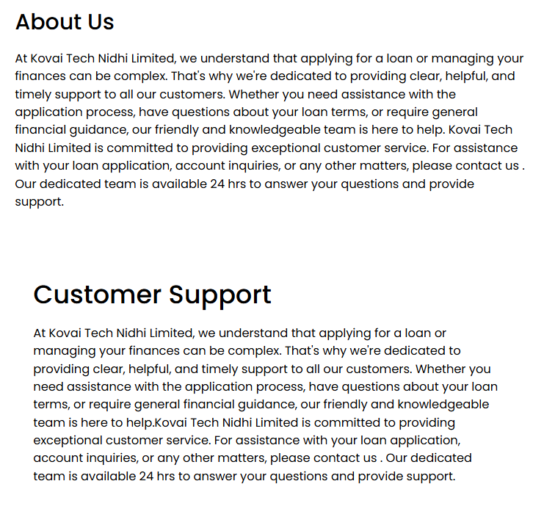

|  |  |  |  |  |  |
| --- | --- | --- | --- | --- | --- |
| Module | Sub Module | Bug | Bug created by | Bug resolved by | remarks |
| Group of companies | Kovai tech nidhi limited | Check the alignment of customer support paragraph | N.Jothipriya |  |  |

4.

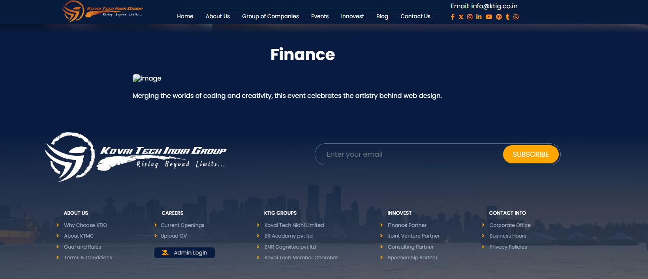

|  |  |  |  |  |
| --- | --- | --- | --- | --- |
| Module | Sub Module | Bug created by | Bug resolved by | remarks |
| events | Finance  IT training  Digital marketing | Check the hidden image while clicking read more |  |  |

5.

|  |  |  |  |  |
| --- | --- | --- | --- | --- |
| Module | Sub Module | Bug created by | Bug resolved by | remarks |
| Admin login | KTIG admin dashboard | Event news login submitting is unable to click |  |  |

6.

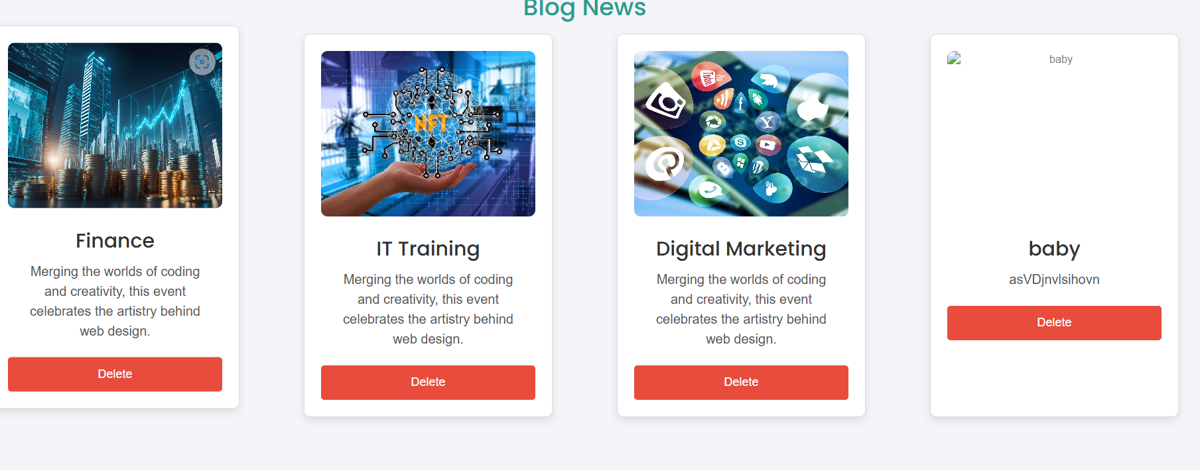

|  |  |  |  |  |
| --- | --- | --- | --- | --- |
| Module | Sub Module | Bug created by | Bug resolved by | remarks |
| Admin login | Blog news in KTIG admin dashboard | Event blogs delete action unable to click |  |  |

|  |  |  |  |  |  |
| --- | --- | --- | --- | --- | --- |
| Module | Sub Module | bug | Bug created by | Bug resolved by | remarks |
| Innovest | 1.Finance partner  2.Join venture partner  3.Consulting partner  4.Sponsorship partner | Multiple time same image showing. Need to delete others | N.Jothipriya |  |  |

8.

|  |  |  |  |  |  |
| --- | --- | --- | --- | --- | --- |
| Module | Sub Module | Bug | Buy created by | Bug resolved by | remarks |
| blog | Latest Blog and news  1.Finance  2.IT training  3.Digital marketing | Check the hidden image while clicking read more | N.Jothipriya |  |  |

|  |  |  |  |  |  |
| --- | --- | --- | --- | --- | --- |
| Module | Sub Module | bug | Bug created by | Bug resolved by | remarks |
| Contact us | Contact details | Add mobile number | N.Jothipriya |  |  |

10.

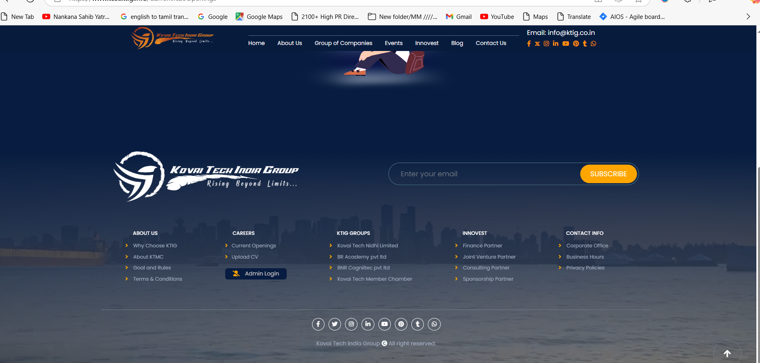

|  |  |  |  |  |  |
| --- | --- | --- | --- | --- | --- |
| Module | Sub Module | bug | Bug created by | Bug resolved by | remarks |
| Careers | Current openings | 1.Check content should be in the center of the screen page.  2.content goes up while clicking current openings | N.Jothipriya |  |  |

11.

|  |  |  |  |  |  |
| --- | --- | --- | --- | --- | --- |
| Module | Sub Module | bug | Bug created by | Bug resolved by | remarks |
| About Us | Goal and rules | 1.Check content should be in the center of the screen page.  2.content goes up while clicking current openings | N.Jothipriya |  |  |

12.

|  |  |  |  |  |  |
| --- | --- | --- | --- | --- | --- |
| Module | Sub Module | bug | Bug created by | Bug resolved by | remarks |
| About Us | upload | 1.Check content should be in the center of the screen page.  2.content goes up while clicking upload cv | N.Jothipriya |  |  |

13.

|  |  |  |  |  |  |
| --- | --- | --- | --- | --- | --- |
| Module | Sub Module | bug | Bug created by | Bug resolved by | remarks |
| KTIG groups | Kovai tech member chamber | URL page is refused to connect | N.Jothipriya |  |  |

14.

|  |  |  |  |  |  |
| --- | --- | --- | --- | --- | --- |
| Module | Sub Module | bug | Bug created by | Bug resolved by | Remarks |
| Innovest | 1.finance partner  2.Joint venture partner  3.consulting partner  4.sponsership partner | Failure to show submodule’s content in center of the page view | N.Jothipriya |  |  |

15.

|  |  |  |  |  |  |
| --- | --- | --- | --- | --- | --- |
| Module | Sub Module | bug | Bug created by | Bug resolved by | Remarks |
| Contact info | Corporate office | Failure to show submodule’s content in center of the page view | N.Jothipriya |  |  |

16.

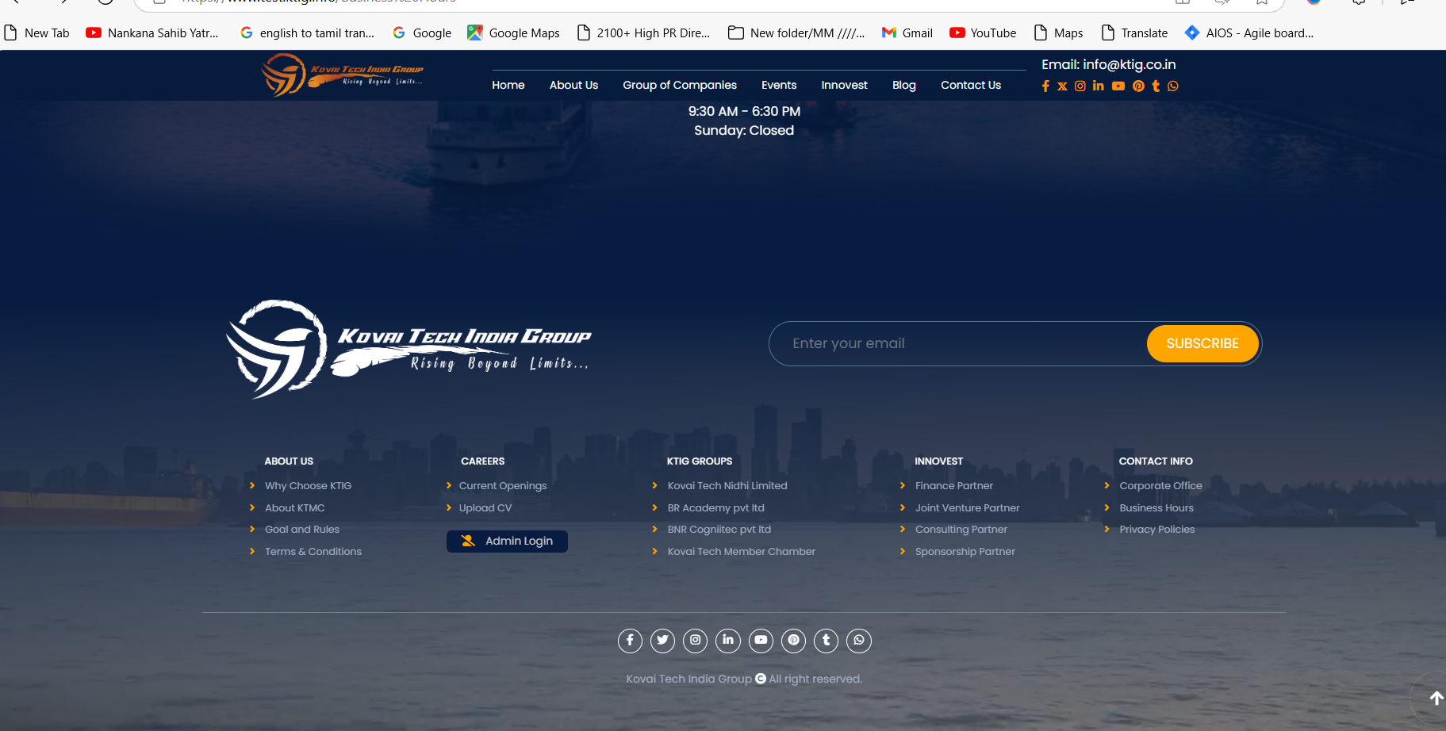

|  |  |  |  |  |  |
| --- | --- | --- | --- | --- | --- |
| Module | Sub Module | bug | Bug created by | Bug resolved by | Remarks |
| Contact info | Business hours | Failure to show submodule’s content in center of the page view | N.Jothipriya |  |  |